**PRAKTIKUM 5**

Nama : Ananta Satya Dhamma

NIM : 18090003

Kelas : 5C

1. Source Code

MatakuliahValidation.php => controller

view-form-matakuliah.php => view

view-data-matakuliah.php => view

1. Url

<http://localhost/Pustaka_booking_anan/matakuliahvalidation>

<http://localhost/Pustaka_booking_anan/matakuliahvalidation/cetak>

1. Capture Output Program

**view-form-matakuliah.php**

**(**<http://localhost/Pustaka_booking_anan/matakuliahvalidation>**)**

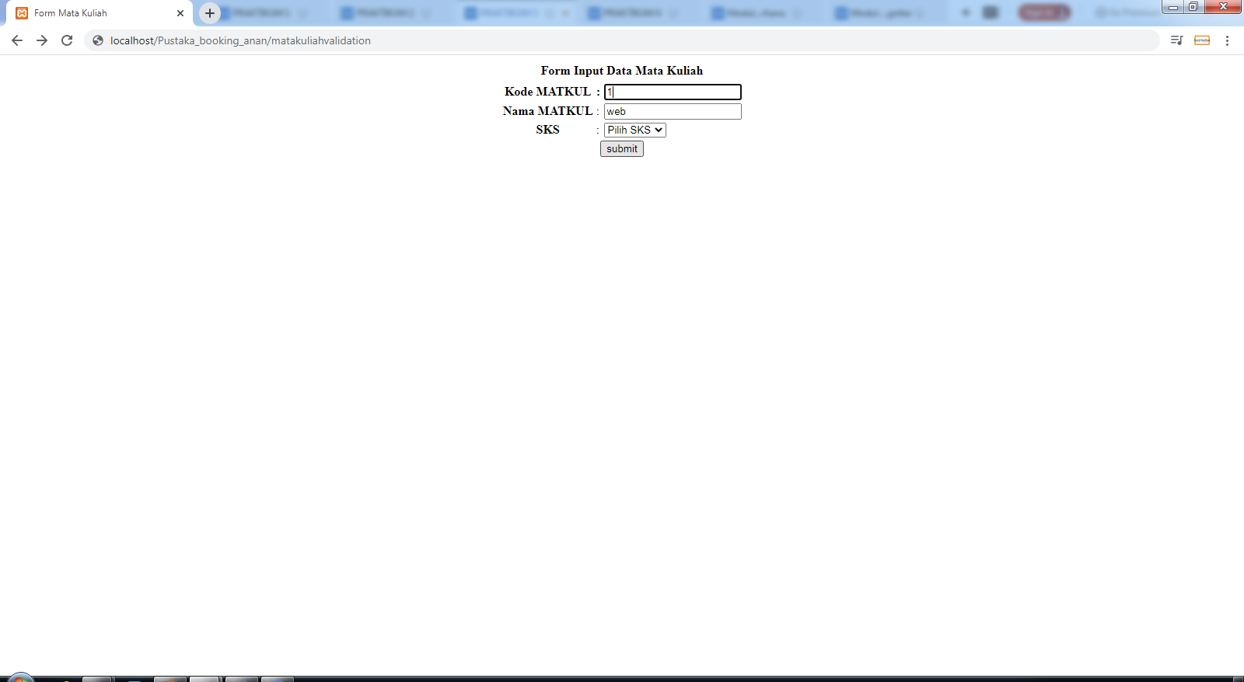

**view-data-matakuliah.php**

**(**<http://localhost/Pustaka_booking_anan/matakuliahvalidation/cetak>)

